# **Lead to Account Matcher - Setup & Deployment Guide**

## 1. Prerequisites

* Salesforce Sandbox or Developer Edition Org
* Admin permissions to create fields, Apex classes, and triggers

## 2. Metadata Setup

Create the following custom fields on the Lead object:

|  |  |  |  |
| --- | --- | --- | --- |
| **Field Label** | **API Name** | **Type** | **Description** |
| Matched Account | Matched_Account__c | Lookup(Account) | Stores the matched Account |
| Matched By | Matched_By__c | Picklist | Values: Domain, Fuzzy, Combined |
| Match Score | Match_Score__c | Number(1,2) | Stores match similarity score (0 to 1) |

## 3. Apex Code deployment

Deploy the provided apex files and triggers given below.

**a. Classes**

* StringMatchUtils.cls
* LeadAccountMatcher.cls
* LeadTriggerHandler.cls

**b. Trigger**

* LeadTrigger.trigger

**c. Test Classes**

* StringMatchUtilsTest.cls
* LeadAccountMatcherTest.cls
* LeadTriggerTest.cls

## 4. Post-Deployment Configuration

* Add Matched_Account__c, Matched_By__c, and Match_Score__c to Lead page layout.
* Ensure that Account page layout has Related leads List view.
* Set field-level security appropriately.

5. Reports & Dashboards

* Create a custom report type: Leads to Account Match Report
* Build a dashboard showing match success rate

Follow below steps.

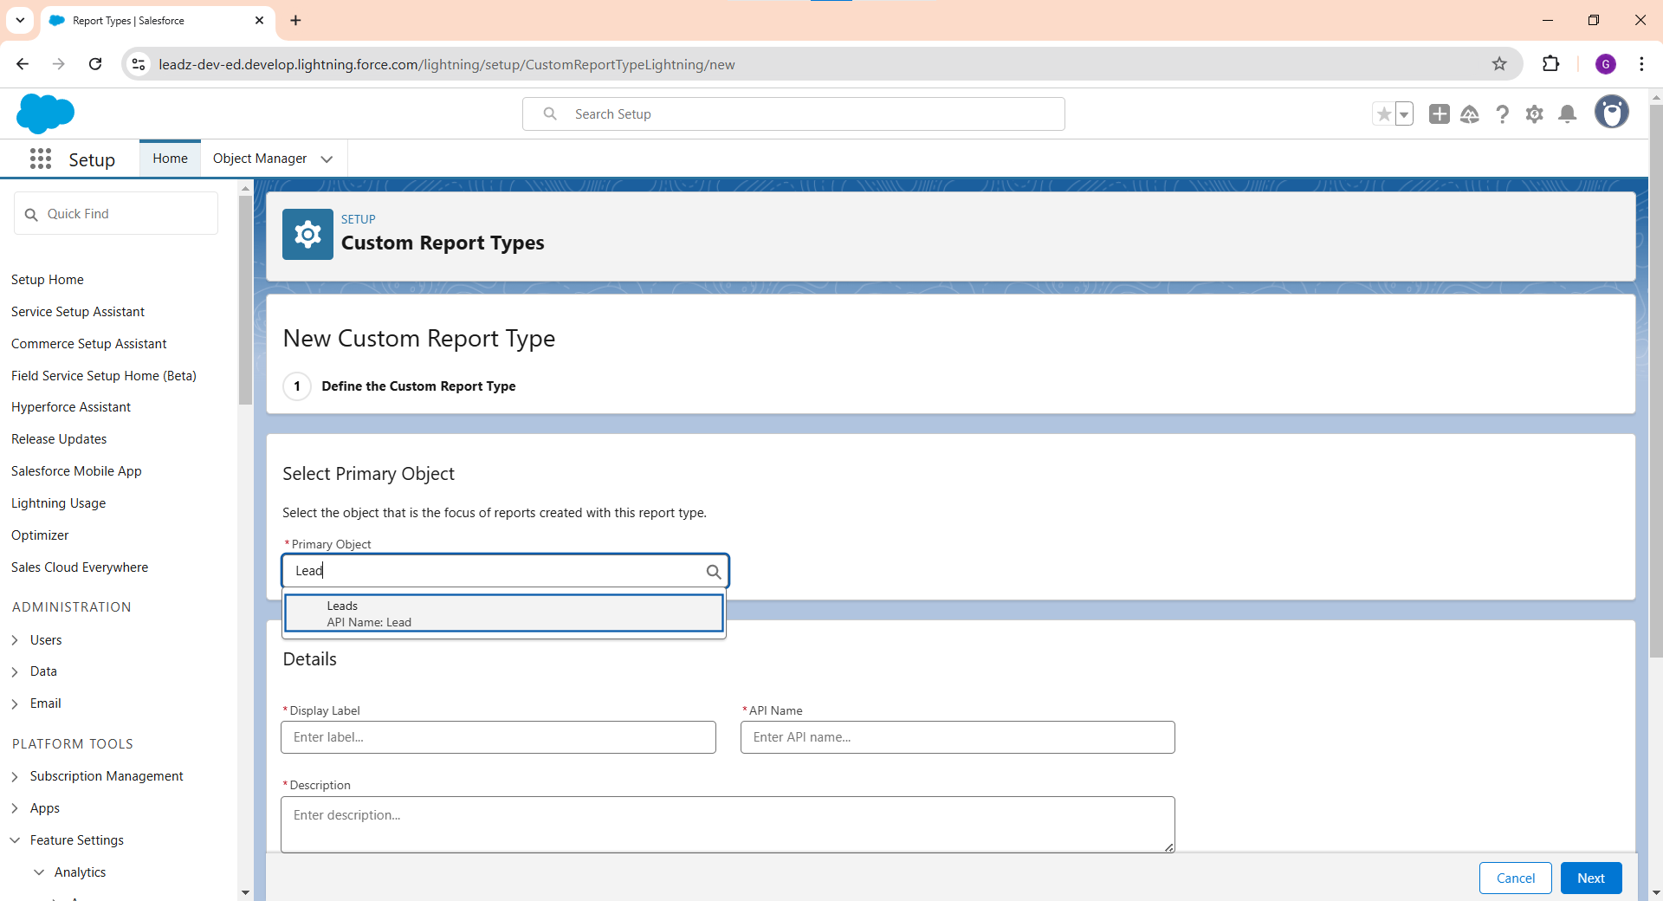

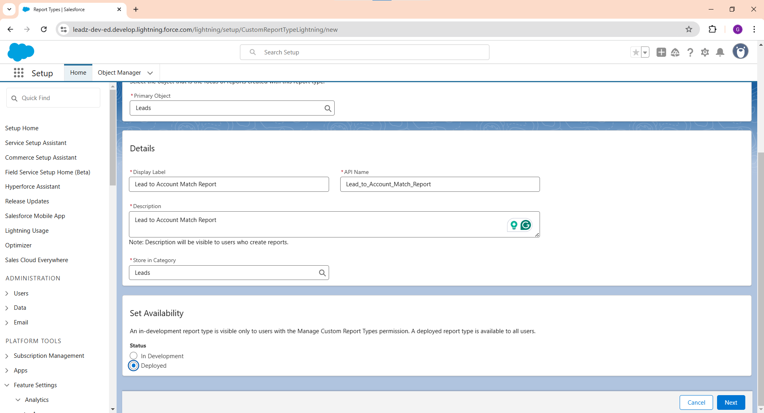

Create a report using the custom report type created above.

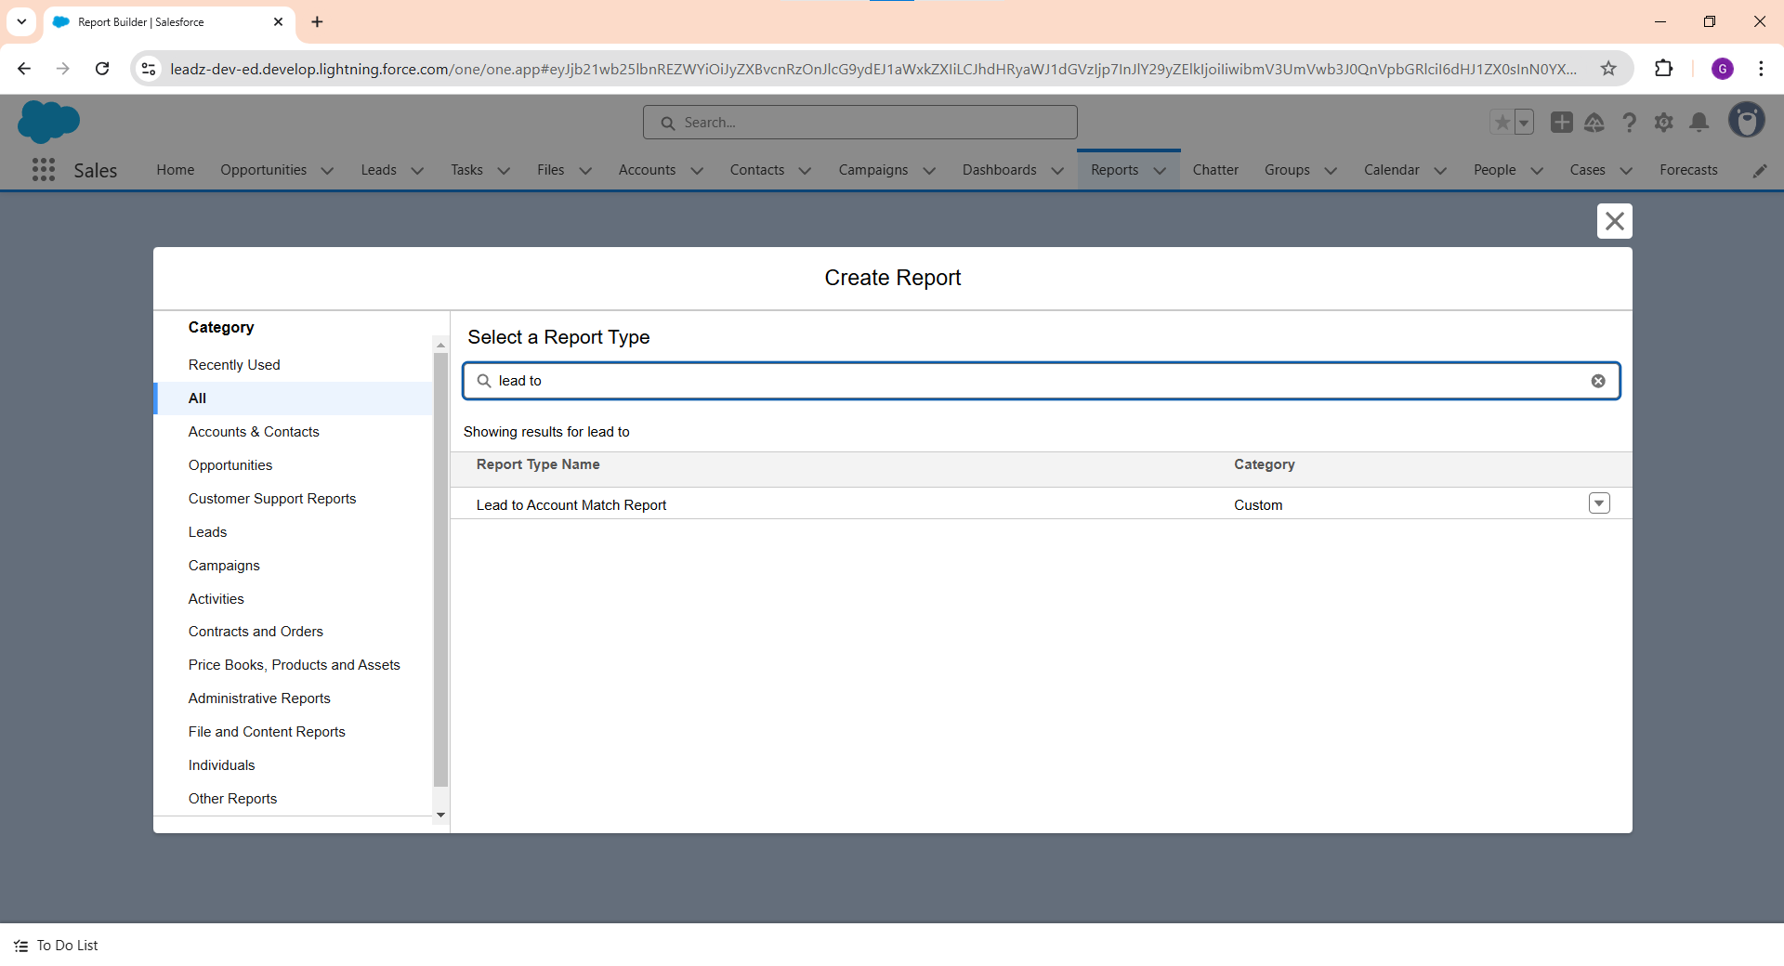

Add the relevant columns from Lead object. Create a row level formula field – Is_Matched to show if Account is Matched to the Lead record.

Formula used - IF(ISBLANK(Lead.Matched_Account__c.Name), 0, 1).

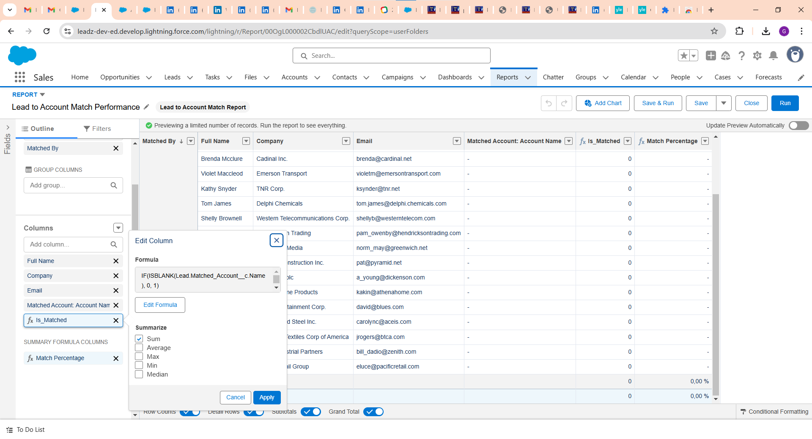

Create a Summary-level formula column - Match Percentage to display Lead to Account match percentage.

Formula - CDF1:SUM/RowCount

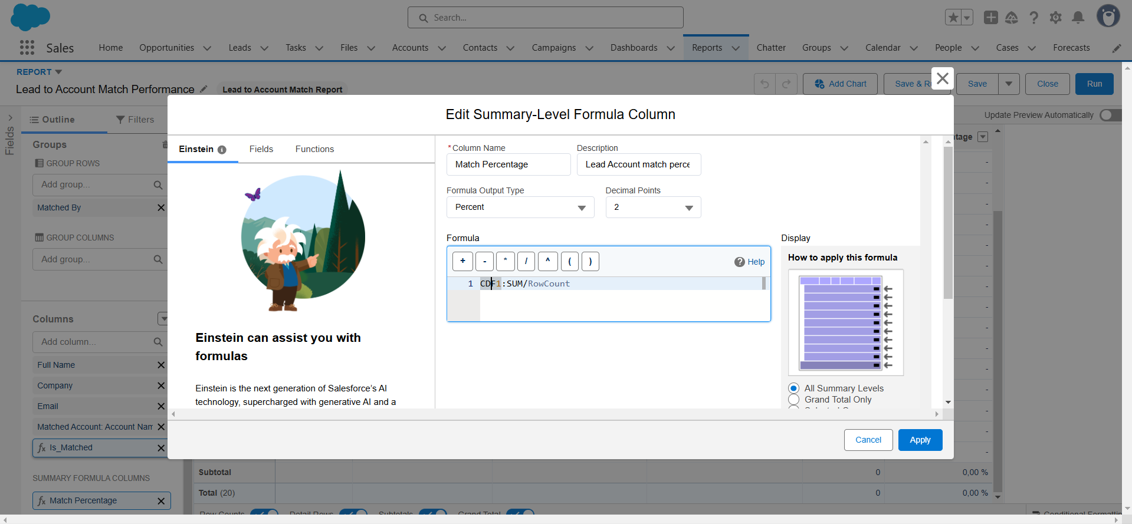

Create a new dashboard.

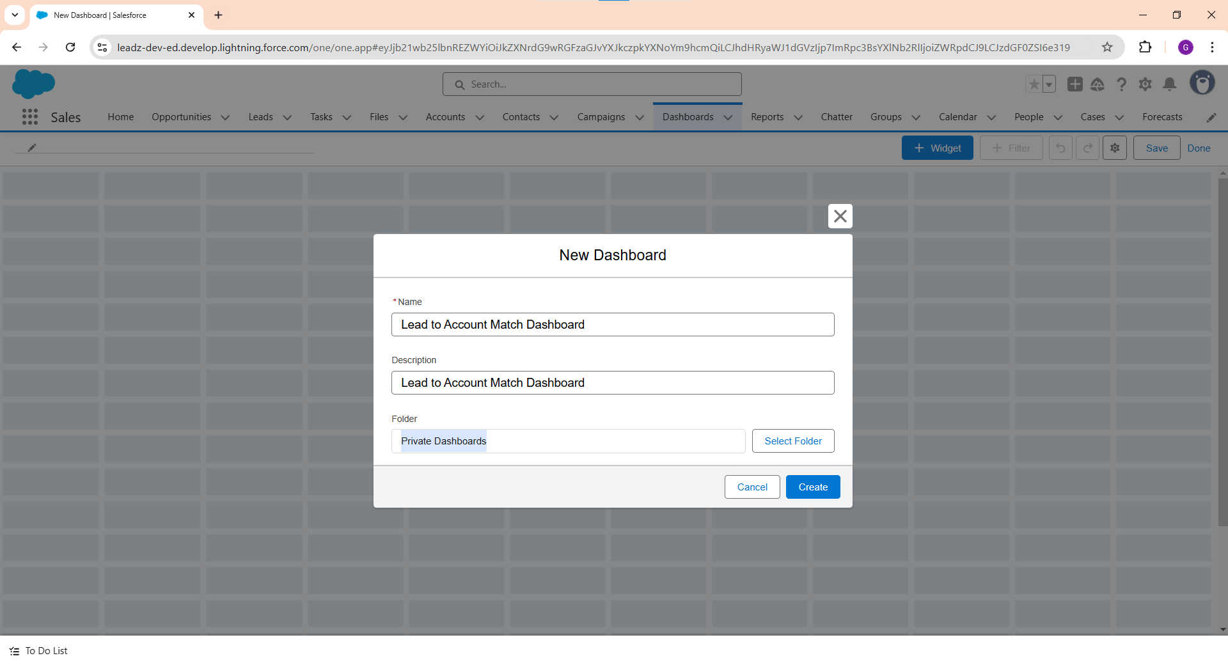

Select Widget > Chart or Table. Select the report created in previous steps.

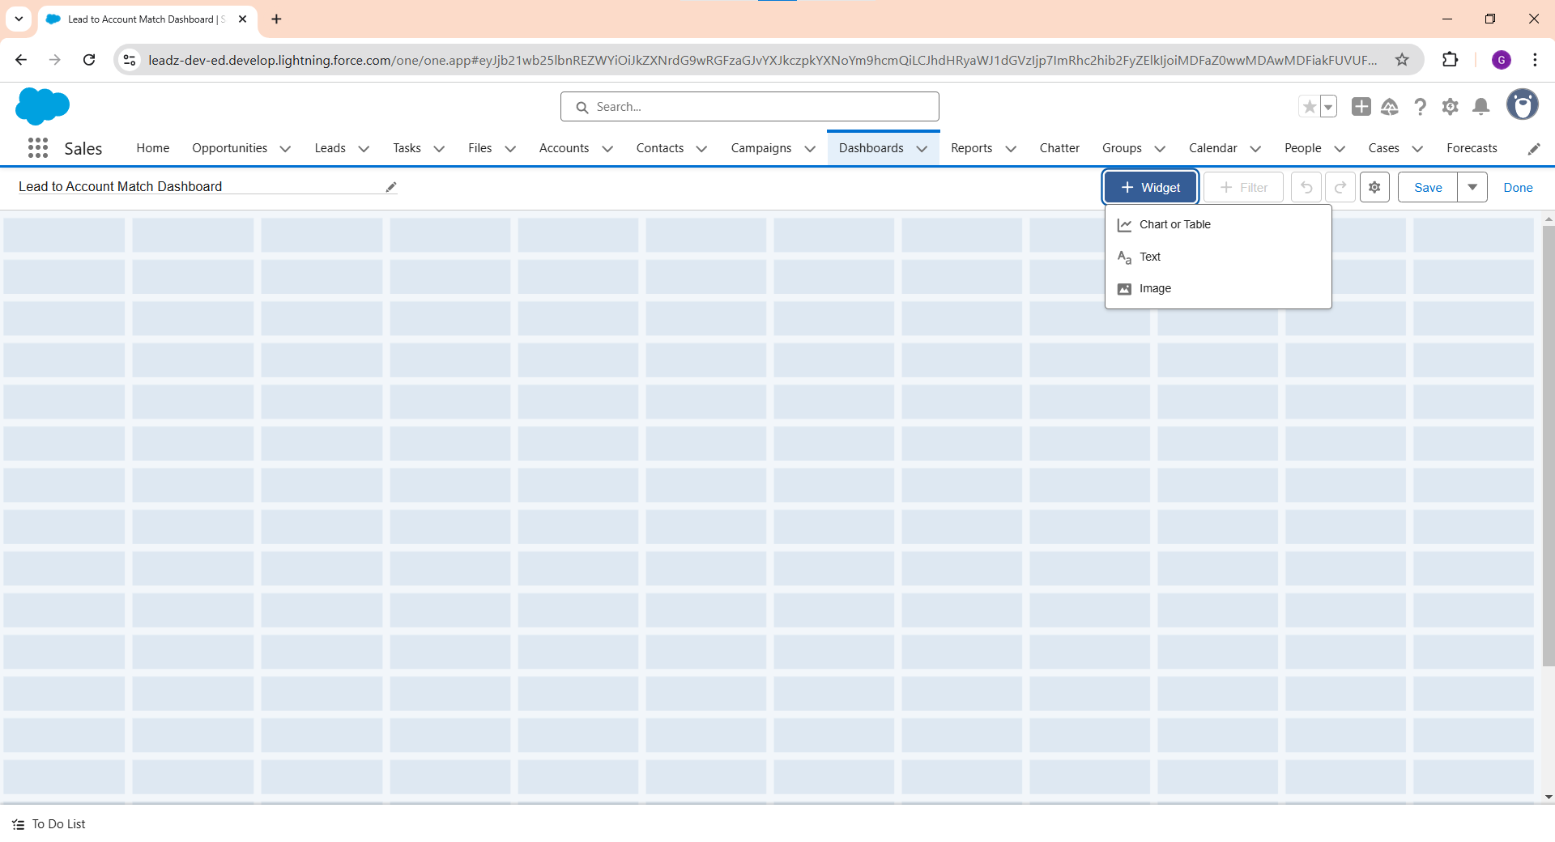

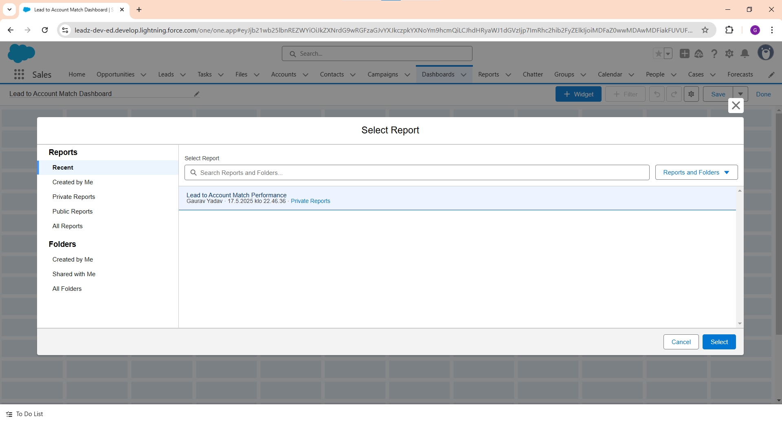

Choose the below 2 widgets and subscribe to a suitable refresh frequency.

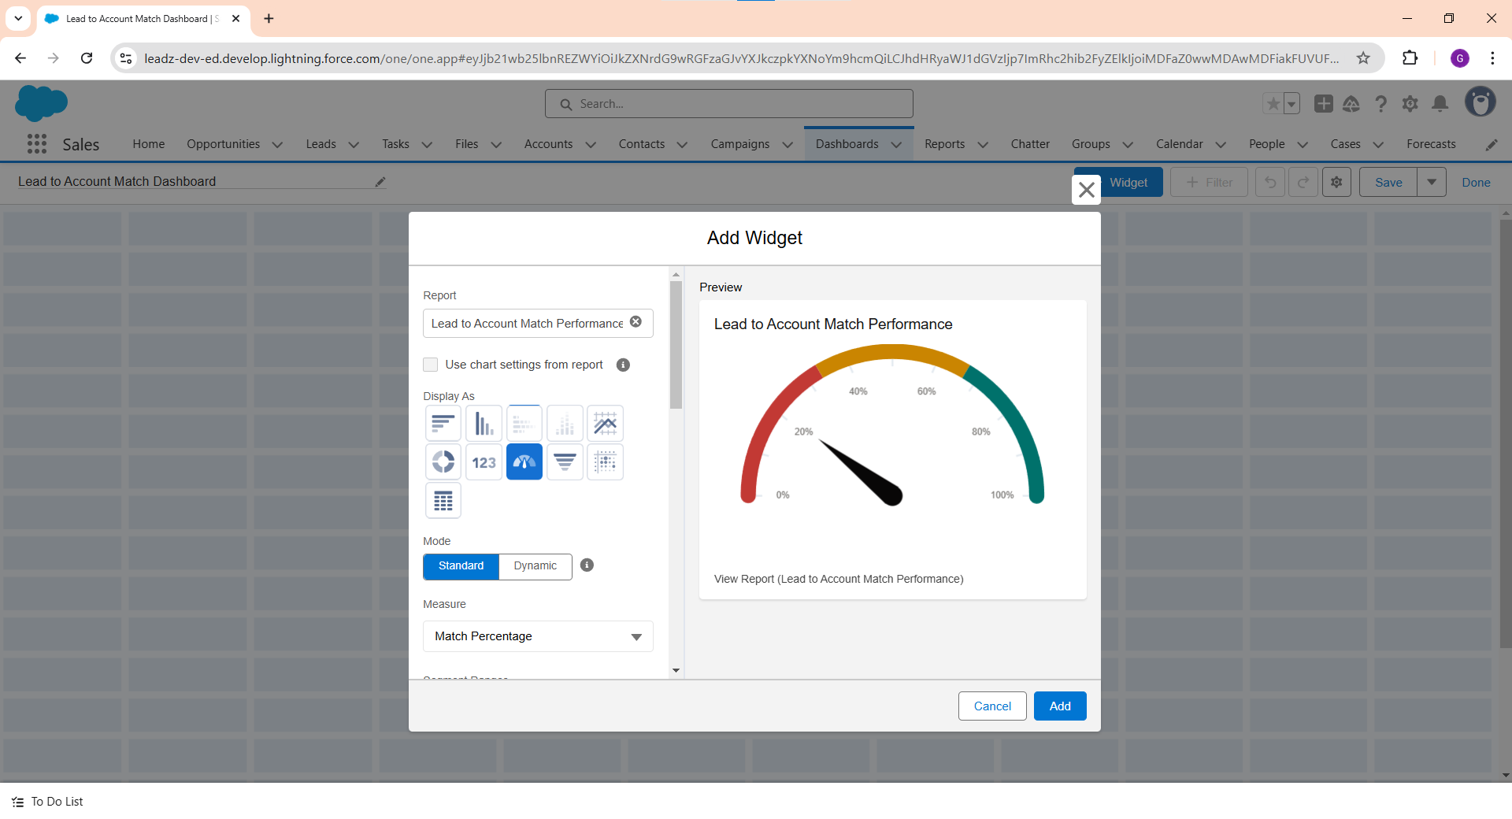

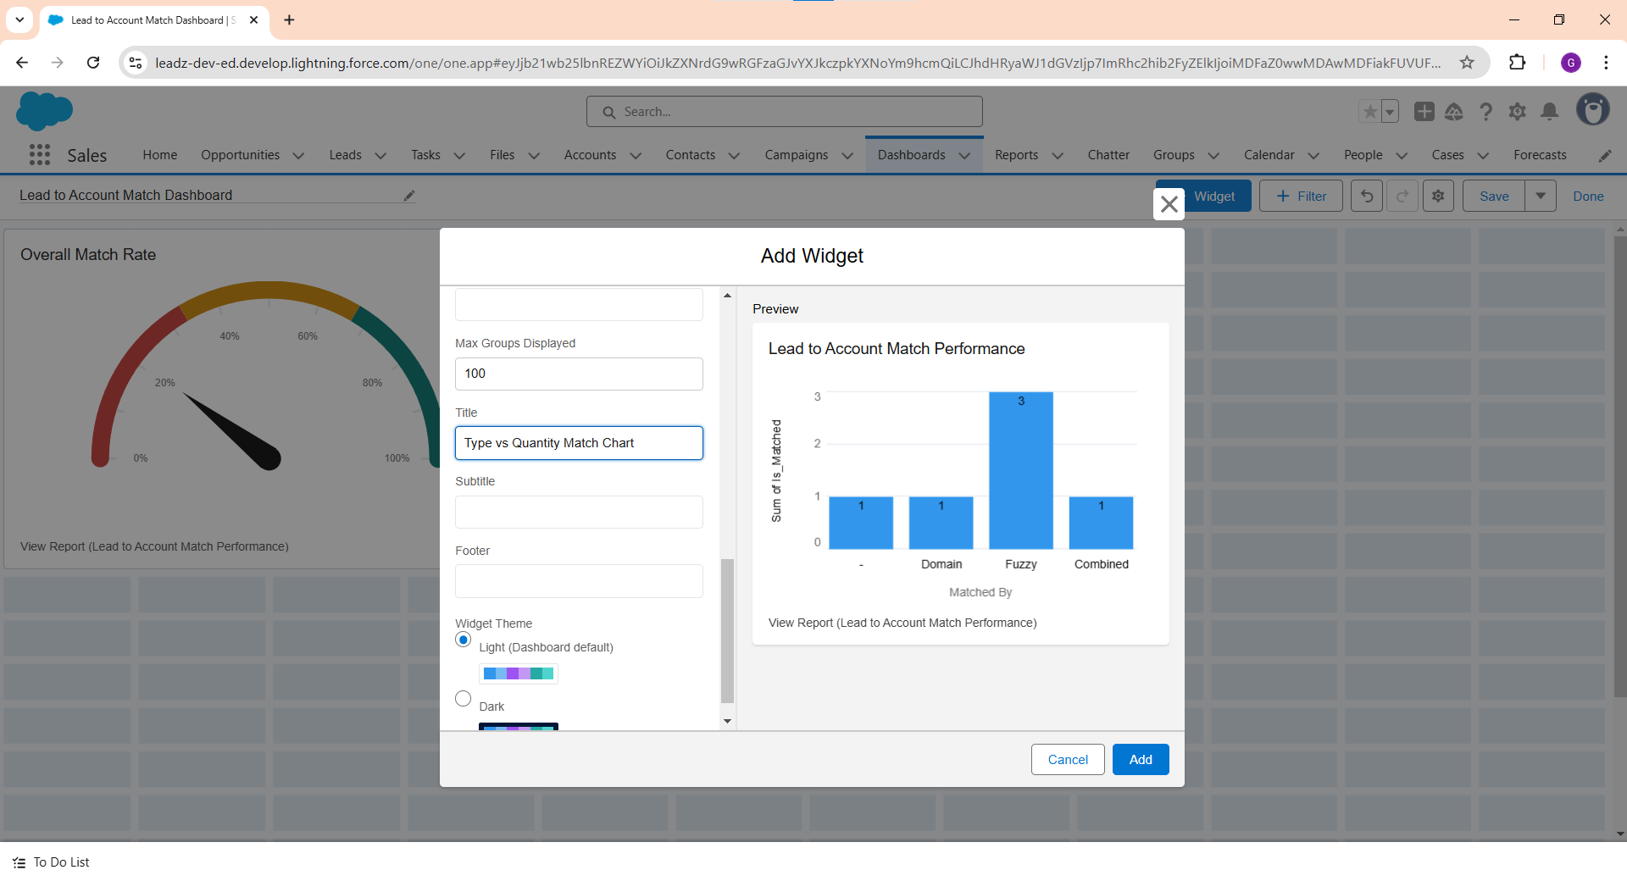

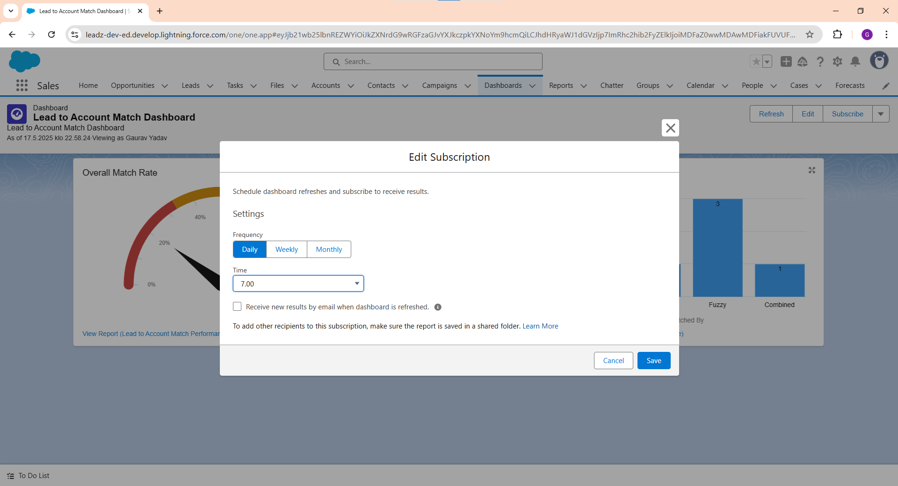

This is how the final dashboard should appear.

